
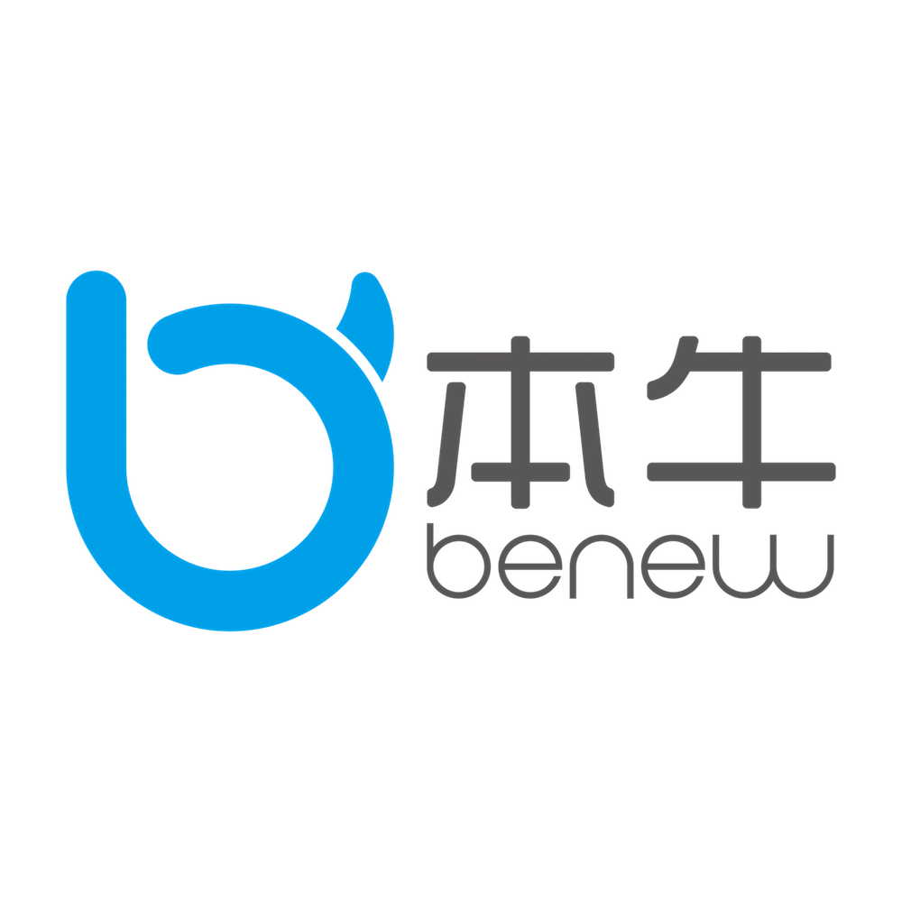

CERTIFICATE
of Achievement

Presented to
李铁柱
Upon the successful completion of

The Primary Customer Service
and in recognition thereof is awarded this certificate on

年 月 日
Litiezhu
李铁柱（签名）：

Training center of the Benewtech

